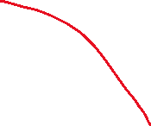

Press ctrl and select to get all 4 variables and drag into the center

Top right > “Show Me” > click on the heatmap logo

Auto organised from top left to bottom right (first hierarchy first followed by next, according to the ranking arranged – first by size, then by colour)

Hover to see the details

Can add and arrange differently to visualize change over different variables